Section 0:

1.create a directory ‘project_id’ & cd ‘project_id’

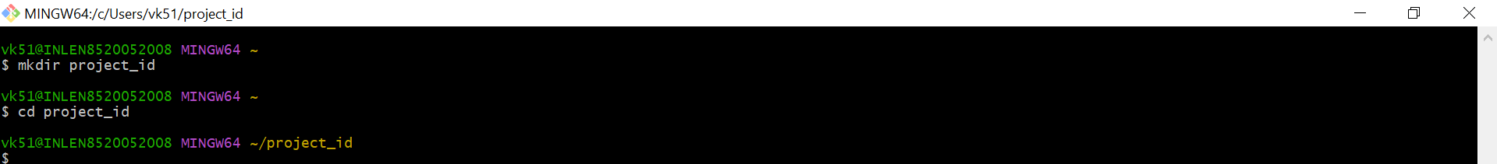

2.initalize git version database

3.create a new file index.html

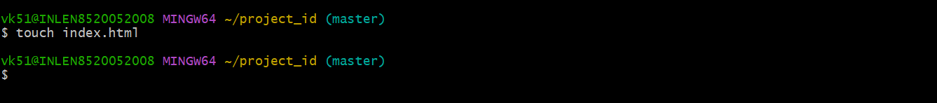

4.check the git status .you should find index.html as untracked file

5.stage the index.html file

6.commit index.html

7.make few changes in index.html file and create a new file info.txt file

9.log all your comments so far

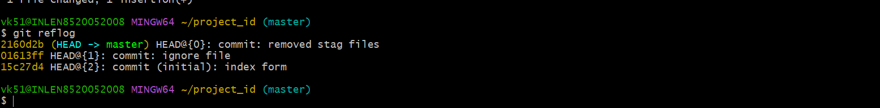

Git Branching :

Section 1

22 .Create an empty directory assignments & cd assignments

23. create a file README.txt inside assignments & write few lines about the contents of assignments folder

24.commit README.txt file

25. Now create a new branch html-assignments

26.switch to html-assignments

27.copy all html assignments inside assignments folder

28.commit html assignments into html-assignments branch.

29.make minor changes into few files belonging to html-assignments branch

30.commit those changed files.

31.switch to master branch

32.make minor changes to README.txt file & commit those changes into master

33.again switch to html-assignments branch

34.make minor changes into few files belonging to html-assignments branch.

35.commit those changes.

36.switch to master.

37.merge html-assignments branch into master .confirm all html assignments are shown in master.

38.finally delete the html-assignments branch.

Section 2:

22 .Create an empty directory assignments & cd assignments

23. create a file README.txt inside assignments & write few lines about the contents of assignments folder

24.commit README.txt file

25. Now create a new branch html-assignments

26.switch to html-assignments

27.copy all css assignments inside assignments folder

28.commit css assignments into html-assignments branch.

29.make minor changes into few files belonging to css-assignments branch

30.commit those changed files.

31.switch to master branch

32.make minor changes to README.txt file & commit those changes into master

33.again switch to css-assignments branch

34.make minor changes into few files belonging to css-assignments branch.

35.commit those changes.

36.switch to master.

37.merge css-assignments branch into master .confirm all css assignments are shown in master.

38.finally delete the css-assignments branch.

Section 3:

22 .Create an empty directory assignments & cd assignments

23. create a file README.txt inside assignments & write few lines about the contents of assignments folder

24.commit README.txt file

25. Now create a new branch js-assignments

26.switch to js-assignments

27.copy all js assignments inside assignments folder

28.commit js assignments into js-assignments branch.

29.make minor changes into few files belonging to js-assignments branch

30.commit those changed files.

31.switch to master branch

32.make minor changes to README.txt file & commit those changes into master

33.again switch to js-assignments branch

34.make minor changes into few files belonging to js-assignments branch.

35.commit those changes.

36.switch to master.

37.merge js-assignments branch into master .confirm all js assignments are shown in master.

38.finally delete the js-assignments branch.

Git Remoting:

Section 3:

1.Create a git hub account if u do not have already

2. Login into git hub account

3.Create a public repository fresherbatch-oct 16

4.commit and push any simple to this repository under assignments directory

Section -4:

1.one developer from project team will create eclipse projects sampleproj and add

Sample source code files .then commit all files through eclipse GIT plugin.

2.collaborate other team members with your github account so that they can also modify the committed files

3.other developers from same team will checkout all files from remote repository this might get conflicts since certain files fail to merge in such case merge it manually .

4.commit and push the sampleproj project

